**Machine Learning Assessment for Severity of Liver Fibrosis for Chronic HBV Based on Physical Layer With Serum Markers.**

Introduction:

Liver is an important organ that performs hundreds of tasks related to metabolism, energy storage, and detoxification of waste. It helps you digest food, convert it to energy, and store the energy until you need it. It also helps filter toxic substances out of your bloodstream.

Liver disease is a general term that refers to any condition affecting your liver. These conditions may develop for different reasons, but they can all damage your liver and impact its function.

Symptoms:

Liver disease symptoms vary, depending on the underlying cause. However, there are some general symptoms that may indicate some kind of liver disease.

These include:

* yellow skin and eyes, known as jaundice
* dark urine
* pale, bloody, or black stool
* swollen ankles, legs, or abdomen
* nausea
* vomiting
* decreased appetite
* ongoing fatigue
* itchy skin
* easy bruisings

Execution:

Double Clink on run.bat file

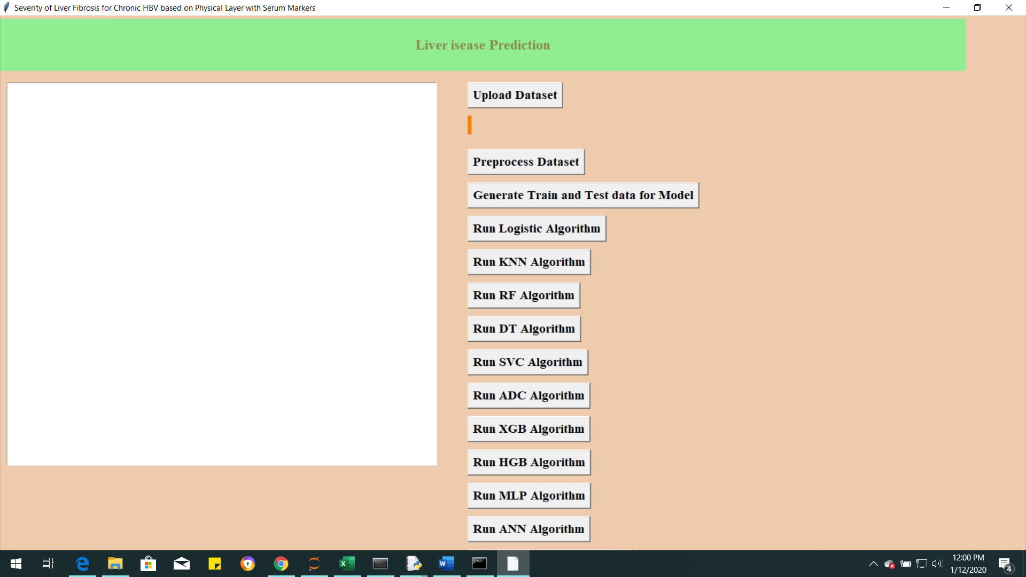

Now click on “Upload dataset” and upload the data from the local drive.

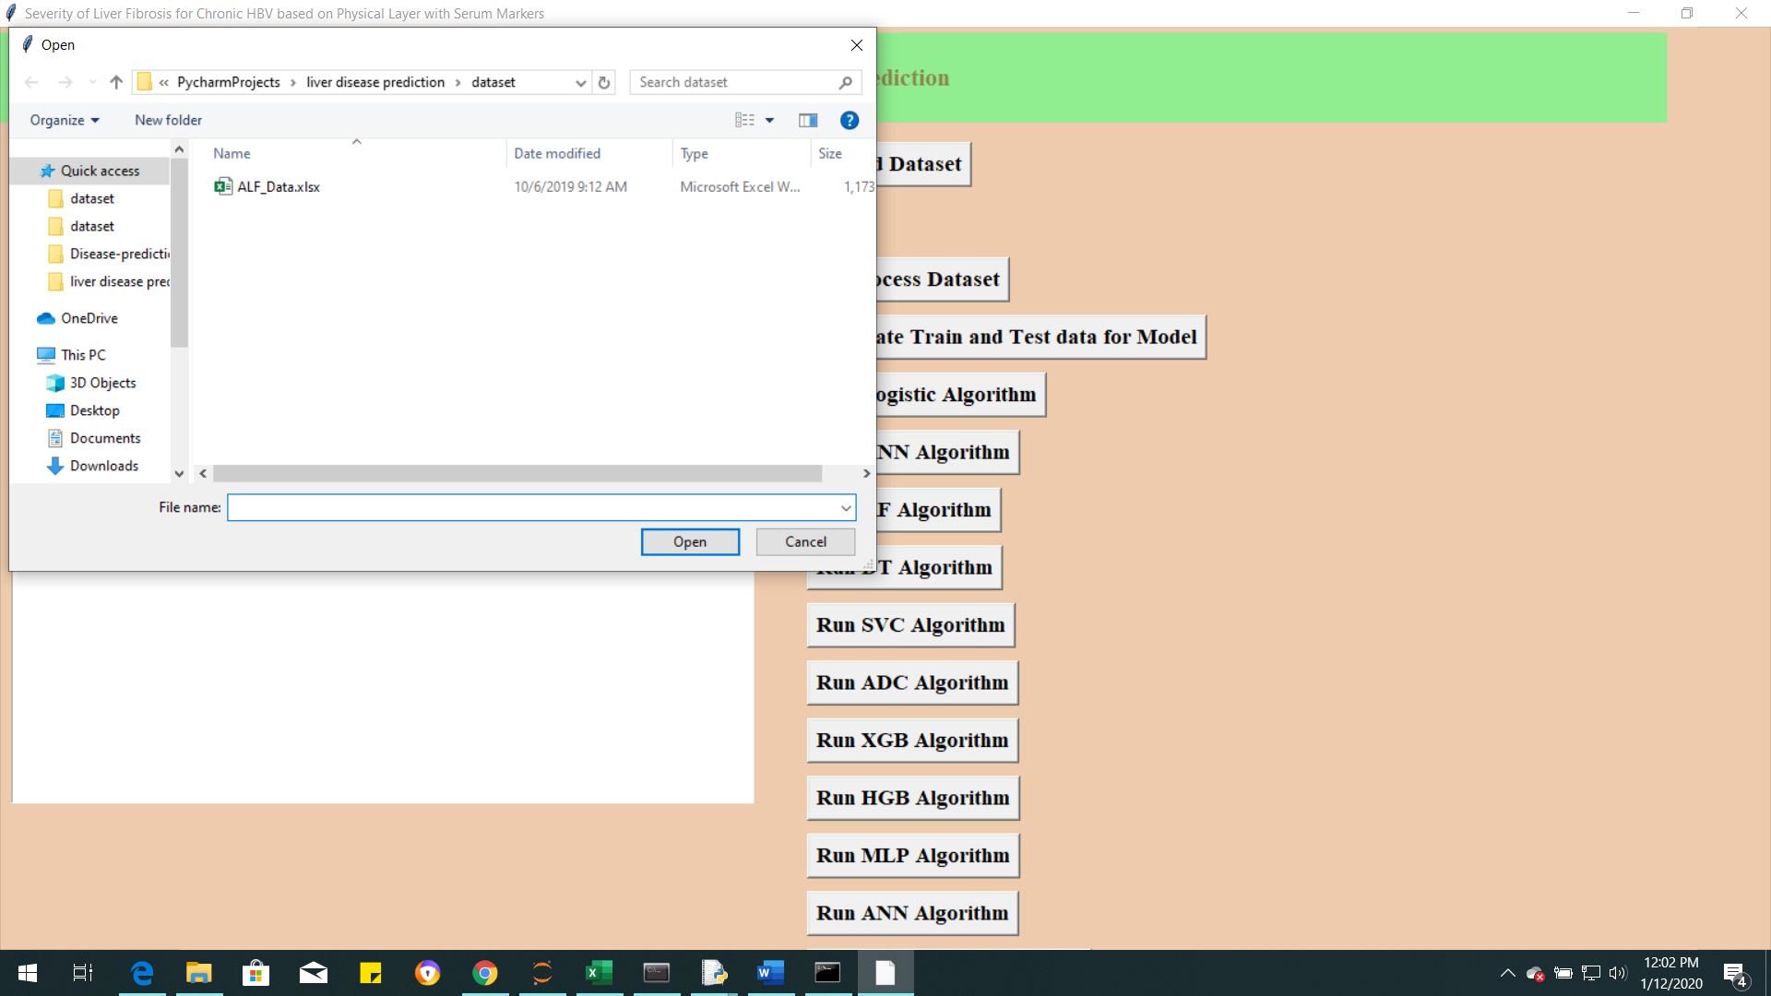

Data is uploaded from the local drive and file is displayed on Screen.

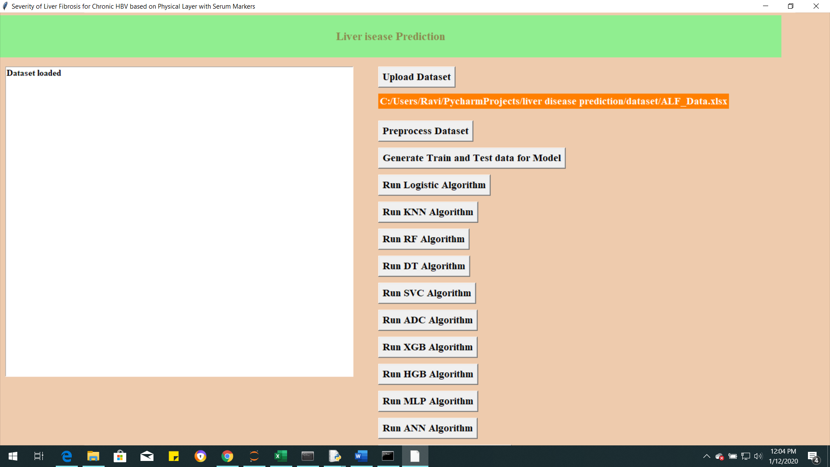

Now click on “Preprocess Dataset”

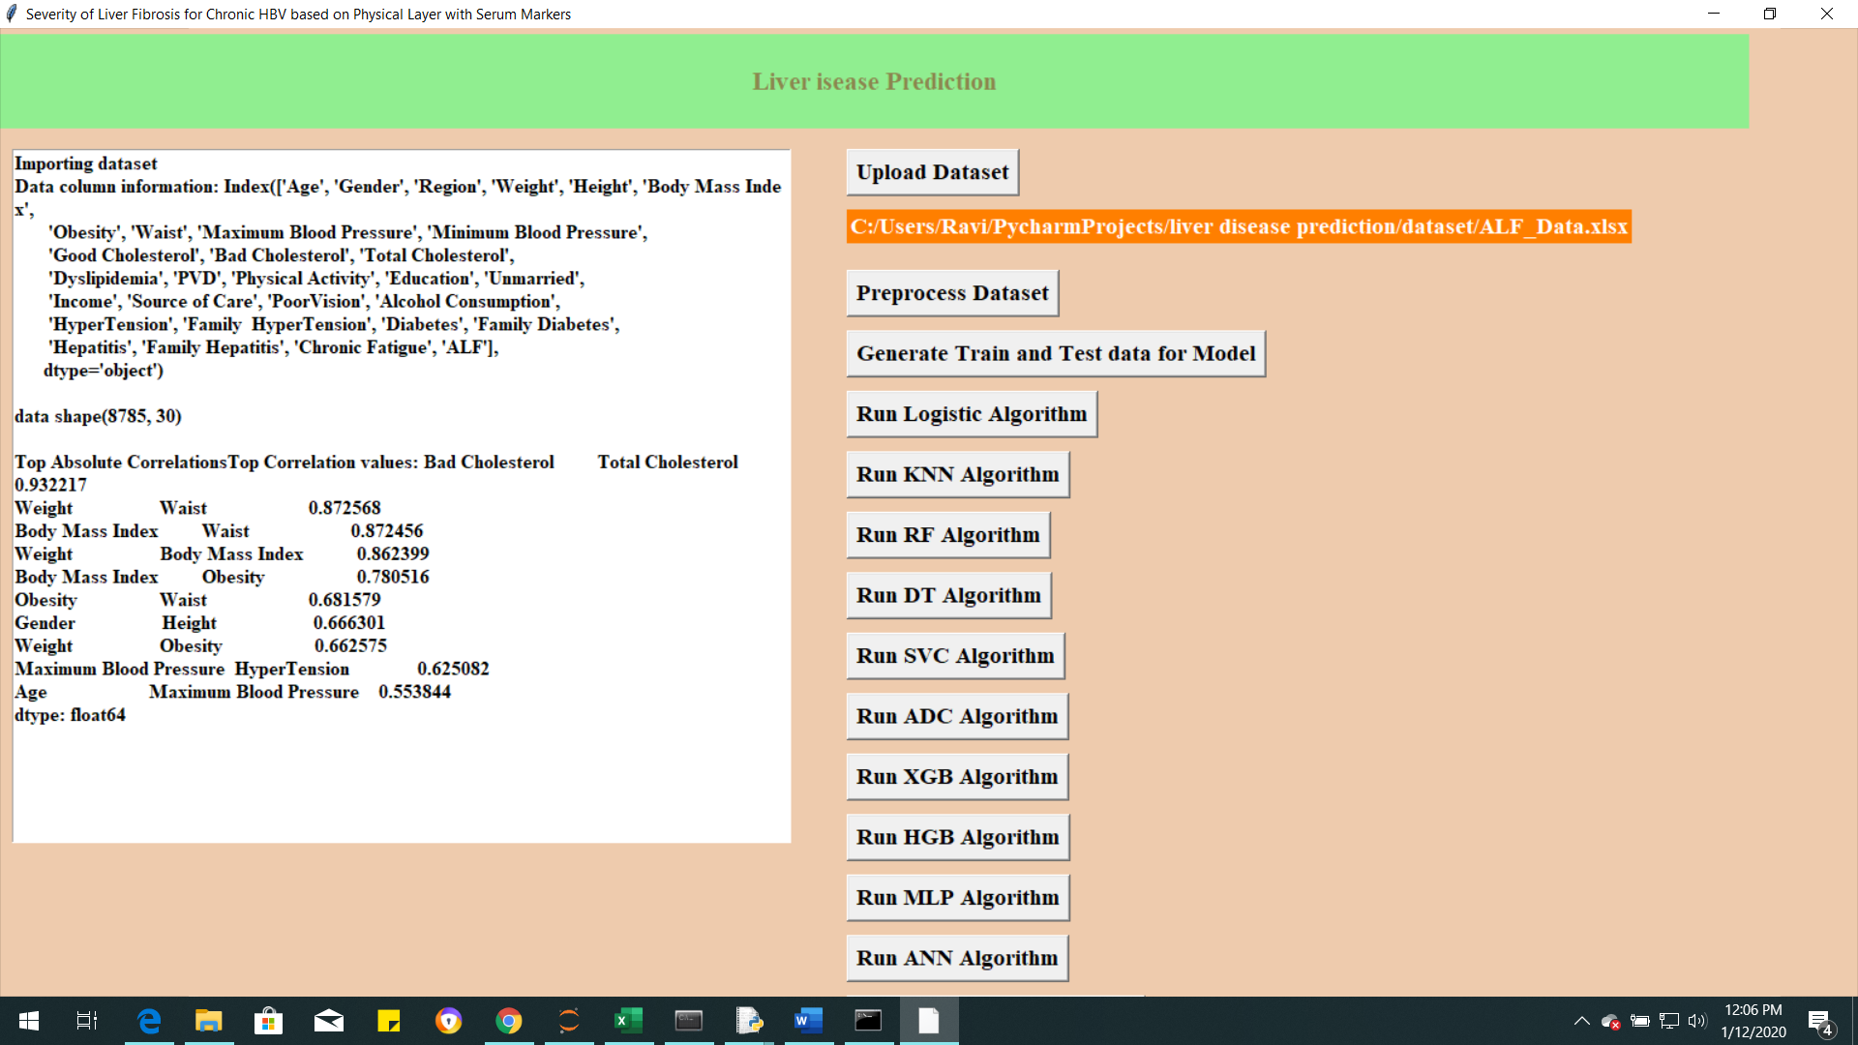

In Data processing cleaning the data(dropping independent variables) filling the missing values) transform the data to same scale. Now click “Generate Train and Test Data for Model”.

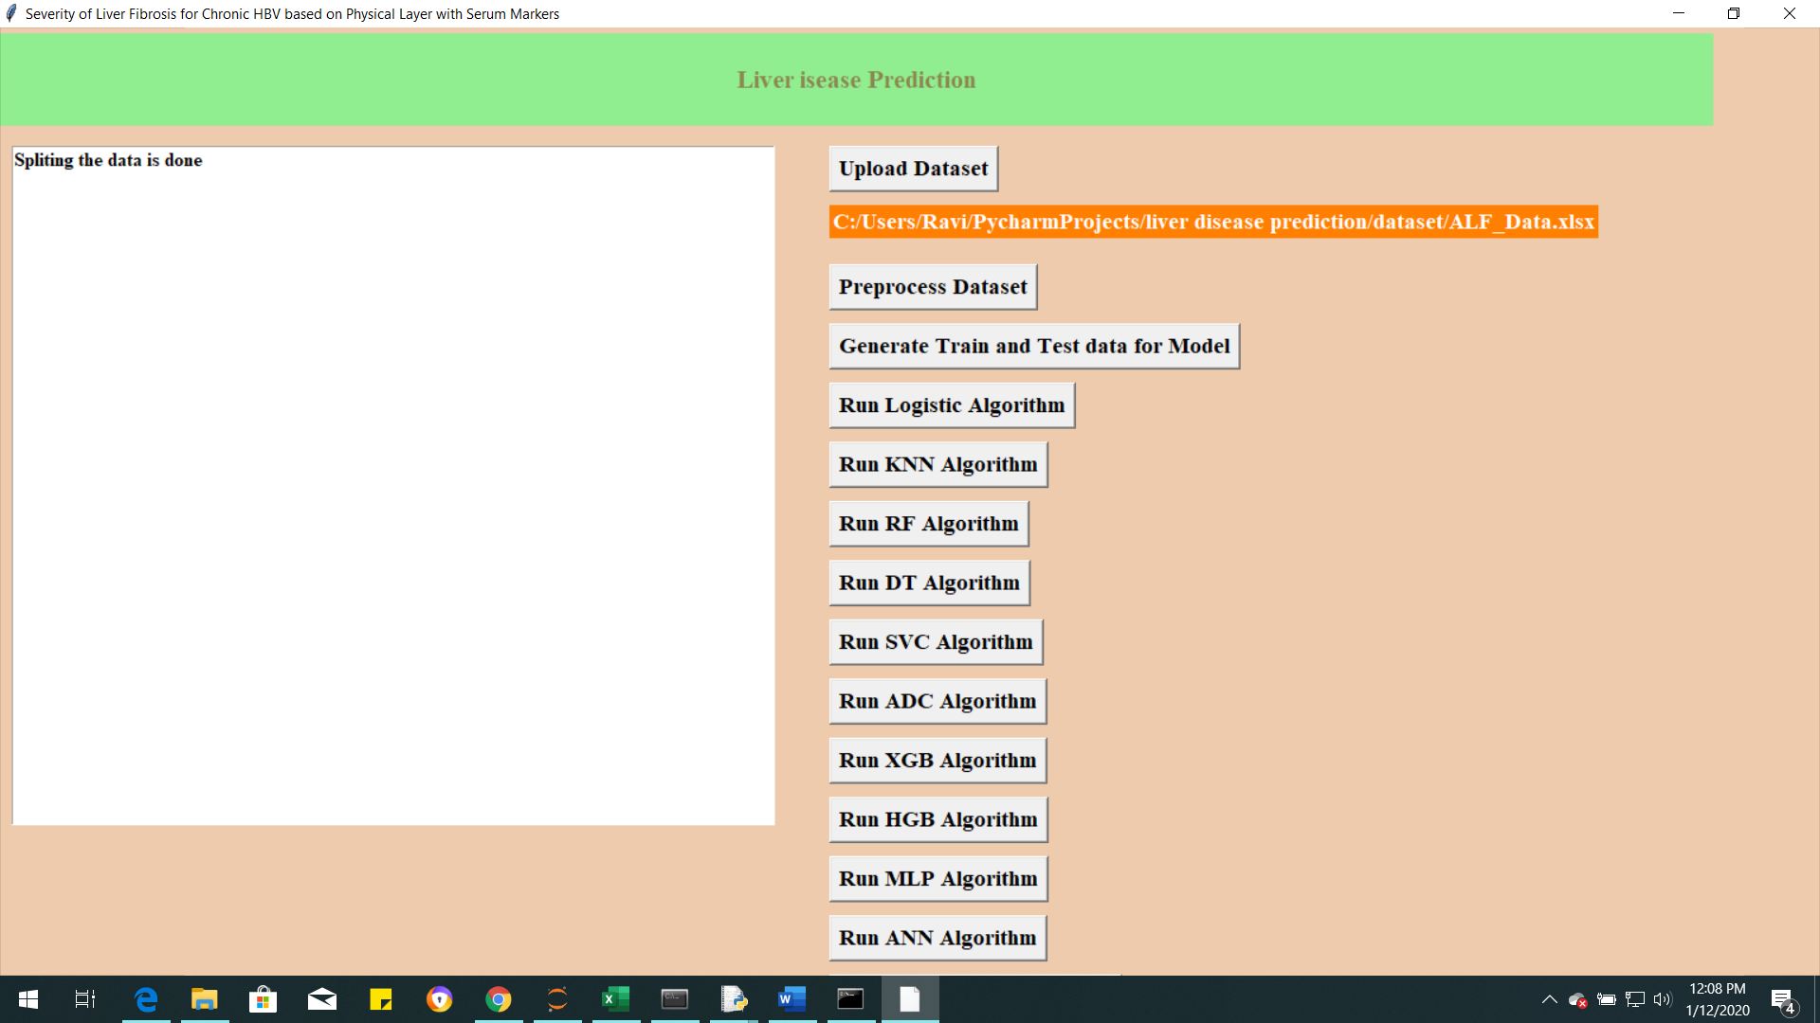

Now run the each model and click on button. For Example I ran ANN Algorithm

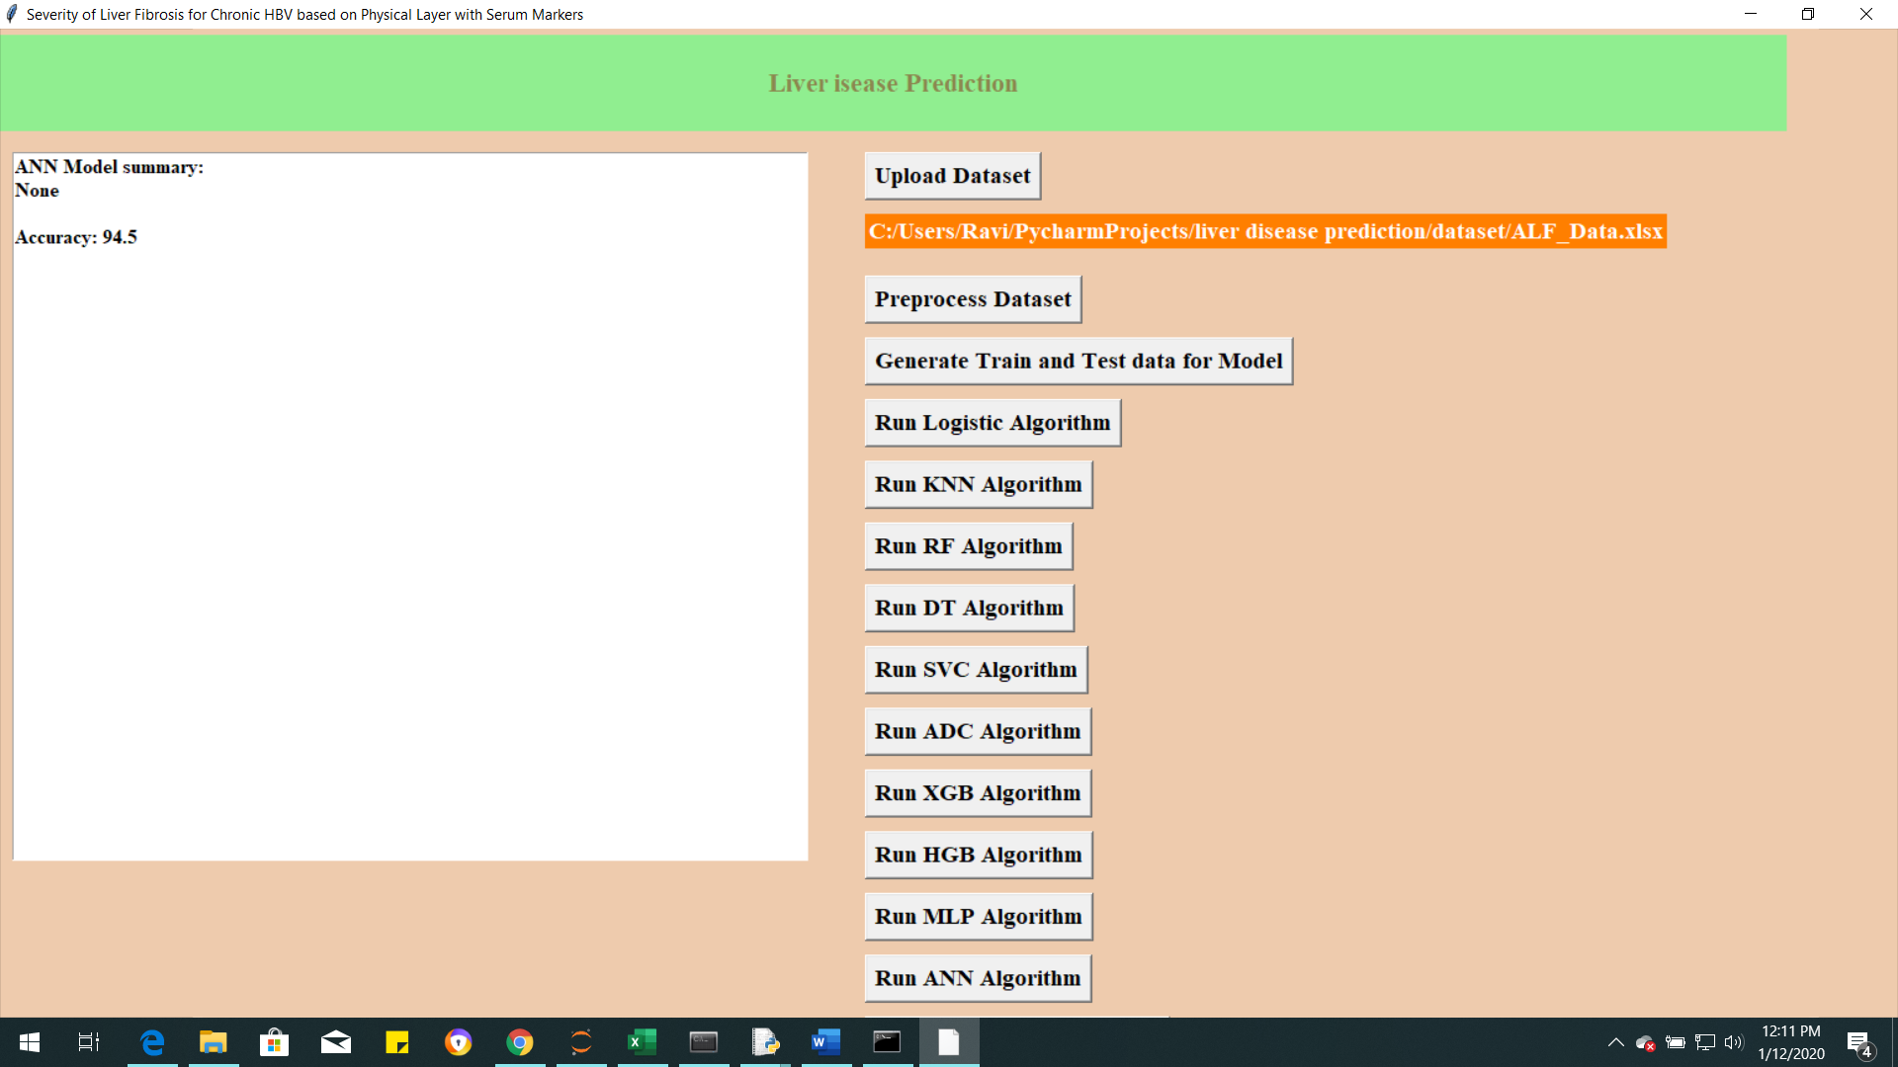

Conclusion:

ANN algorithm performed well compared to other algorithms.